[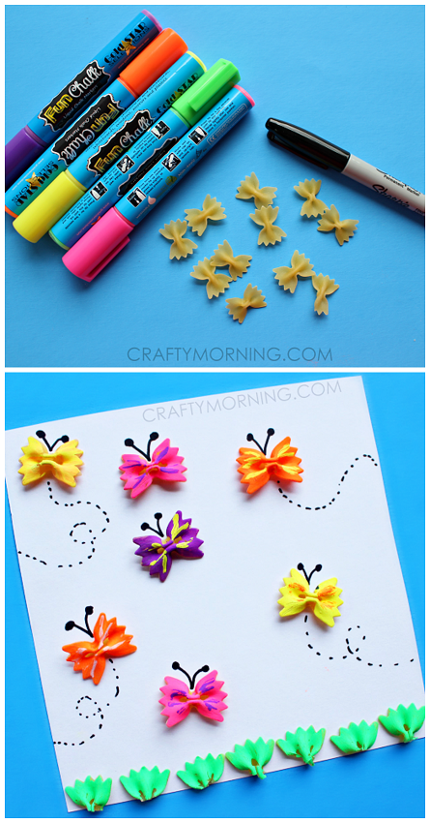](http://www.craftymorning.com/wp-content/uploads/2015/07/noodle-butterflies-craft-for-kids.png)[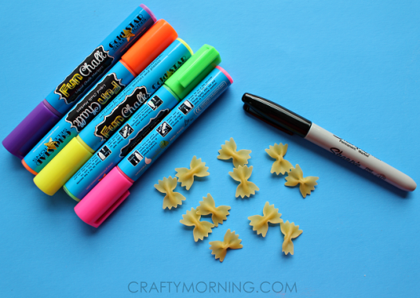](http://www.craftymorning.com/wp-content/uploads/2015/07/bow-tie-noodle-butterfly-kids-craft.png)[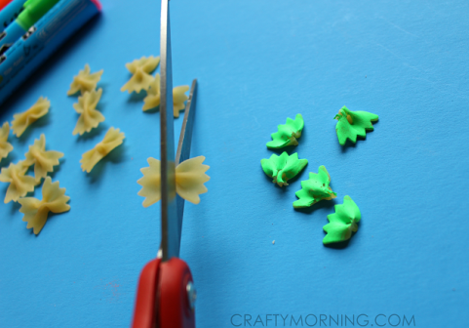](http://www.craftymorning.com/wp-content/uploads/2015/07/noodle-butterfly-craft-for-kids.png)

[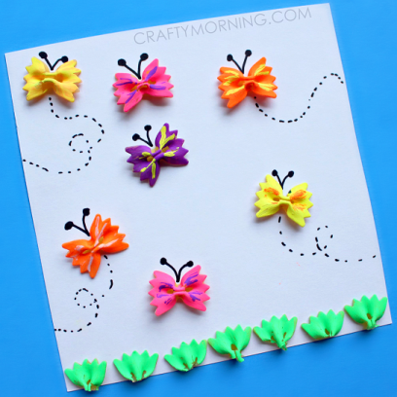](http://www.craftymorning.com/wp-content/uploads/2015/07/bow-tie-noodle-butterflies-craft-for-kids-.png)